EXPERIMENT NO. 3

Data Aggregation: Aggregate data by grouping rows based on a specific attribute and computing summary statistics, such as mean, median, or count.

1. **Compute Mean**

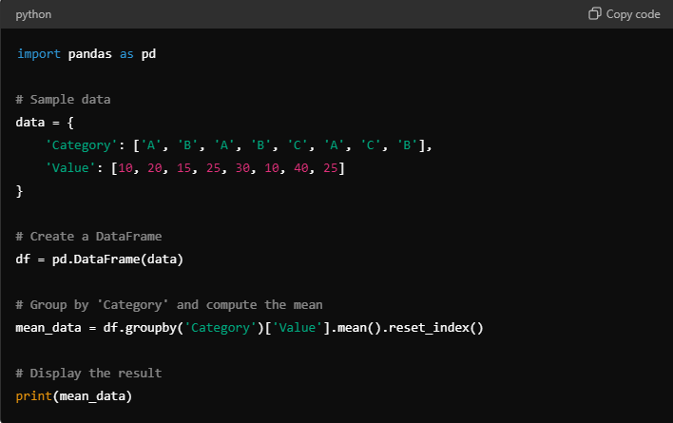

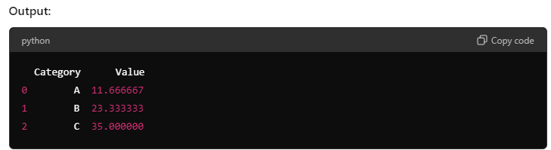

1. **Compute Median**

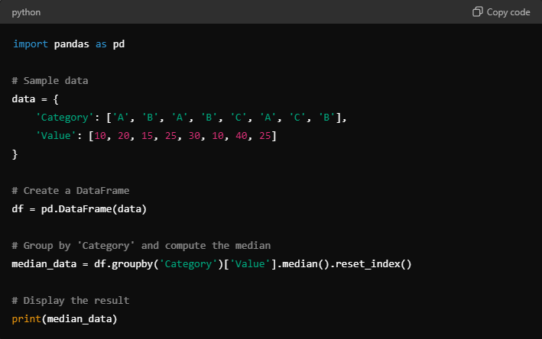

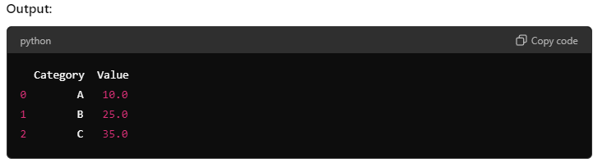

3. **Compute Count**

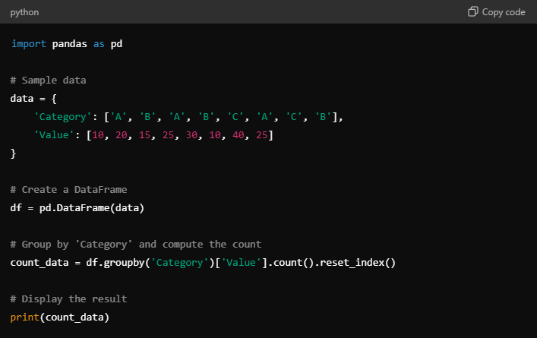

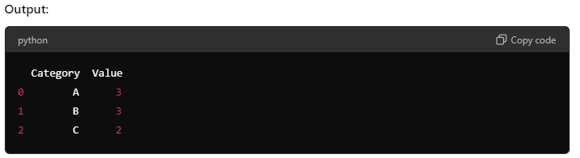

Aggregate data by grouping rows based on a specific attribute and computing summary statistics like mean, median, and count:

